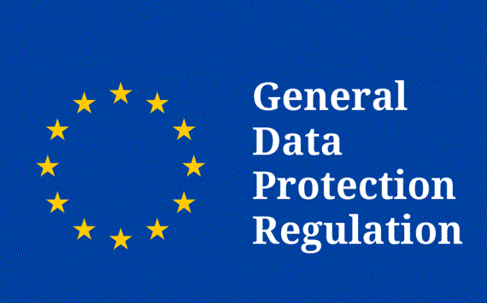

THE PROTECTION OF YOUR PERSONAL DATA IS IMPORTANT TO US. WE HAVE STARTED TO TAKE ALL NECESSARY MEASURES TO COMPLY WITH THE NEW EUROPEAN PERSONAL DATA PROTECTION REGULATION (GDPR).

The Regulation no. 2016/679, repeals Directive 95/46, which entered into force on 25 May 2016. From 25 May 2018, the new GDPR (GDPR) regulation aims to protect the personal data of individuals, in their safe circulation. The rules governing the processing of personal data by private companies and public authorities are harmonized across the EU. The GDPR is directly applicable in all EU Member States without an implementing act.

